Zoho Desk additional requirements for maintenance side ticketing system

Ticket filter:

All Views

All Tickets

Closed Tickets

Customer Responded Tickets

Missed Chats

My Tickets

My On Hold Tickets

My Open Tickets

My Overdue Tickets

My Response Overdue Tickets

On Hold Tickets

Common Reasons a Ticket Is Put "On Hold":

1. Waiting for customer response (e.g., more info needed)
2. Pending third-party/vendor action
3. Blocked by another task or ticket
4. Internal team needs more time or approval
5. Scheduled for future action (e.g., maintenance)

Open Tickets

Overdue Tickets

Tickets for review

Response Overdue Tickets

SLA Violated Tickets

Unassigned Open Tickets

-------------------------------------------------------------------------------------------------------------------------

Clicking into view ticket:

Comment

* Is like the description of the ticket

Resolution

* Once you solved the ticket you can write how you solved it in here, and then save it as a template

Time Entry

* (no need lah)

Attachments

* Pictures, files, videos etc

Activities

* Basically you can write a reminder for you to call / meet / tasks to do in the future for this specific ticket

History

* Ticket editing history

**📞 Contact Info**

These fields are about the **person who submitted the ticket** (the requester or end-user).

* **Name (yi qi / yiqi)** – The customer's name (may be first and last shown separately or repeated).
* **Email (stuff@mailsac.com)** – Contact email for follow-up or notifications.
* **Phone (0121212333)** – Contact number for calls or SMS updates.

**🔑 Key Information**

Details about the current handling of the ticket:

* **Ticket Owner: Pick / Unassigned**
  + The **agent currently responsible** for the ticket.
  + "Unassigned" means **no agent has picked it up yet**.
* **Status: Open**
  + Indicates the ticket is **active and waiting to be resolved**. (assigned is another thing, not on status, shows if it is currently being worked on by someone)
  + Can change to **On Hold**, **Escalated**, or **Closed** depending on progress.

When status escalated

* Was not resolved within a certain time (SLA breach risk)
* Requires expertise beyond the current assignee's level
* Is critical or high priority (e.g., system outage)
* Involves an unhappy customer needing urgent attention

🔄 What Happens When a Ticket is Escalated:

1. Reassigned to a senior support agent, specialist, or manager
2. Priority may be increased (e.g., from medium → high)
3. Tracked more closely, sometimes flagged to supervisors
4. SLA timers may change depending on system settings

* **Due Date: 03 Aug 01:51 PM**
  + The **SLA deadline** by which the ticket is expected to be resolved.
* **Late by 2 days 2 hours**
  + The ticket **missed its SLA** and is currently **overdue** by this amount of time.
* **Tags: -**
  + Keywords used to **label** or **group** similar tickets (none added yet).

**🧾 Ticket Information**

More specific details about the nature of the ticket and how it came in:

* **Phone: (012) 121-2333**
  + Repeats the contact number (formatted differently).
* **Product Name: -**
  + Could be used if the ticket relates to a **specific product** or service (not specified).
* **Skills: -**
  + Can be used to route tickets to agents with **specific expertise** (none selected).
  + Need to do automation assignment rules first so that it can automatically assign to the right person with the right skills (also means you need to define what the skills are first)
    - Also make sure to set assignment rule to on ticket create + on ticket edit so that when we add French onto the skill it will automatically assign it to that person.
* **Category: General**
  + Classifies the **type or theme** of the ticket.
  + “General” means it's not assigned to a more specific category like billing, technical, etc.

**🧩 Additional Information**

Extra ticket metadata used for sorting, automation, or filtering.

* **Priority: Low**
  + Indicates the **urgency level** of the ticket (e.g., Low, Medium, High, Urgent).
* **Channel: Twitter**
  + Shows the **origin of the ticket** — in this case, a Twitter message or mention.
  + Other possible channels: Email, Phone, Web form, Chat, etc.
* **Classifications: of the ticket**
  + Question
  + Problem
  + Feature
  + Others

Suggested knowledge base:

* Can paste stuff that is similar to previous issues

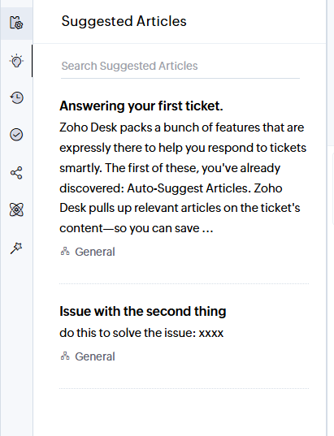

Settings for Customization:

* Changing the field for creating a new ticket for different users who have different roles.

Adding and Setup Skill + edit

* + - Can create new skill (like French) + new skill type (like language)
* Skill Name
* Skill Type
* Description
* Criteria
  + Specify the criteria to be met for associating this skill to tickets.
* Associate agents with this skill to ensure that only tickets matching the skill are assigned to them.

Adding automation

Direct AssignmentDirect

* Auto Assignment can be active when ticket is created and / or edited
* Add target for this Rule
* Tickets coming soon (where the ticket coming in from)

- Any Department

* Criteria (what are the circumstances for this assignment to automatically assign)
  + Skill based
    - is empty
    - is not empty
    - contain all of
    - contain any of
    - contain none of

(skill to add at the end)



* + Ticket creator
    - Is
    - Isn’t

(user)



* + Is escalated (only: is)



* + Status you can add the thingy
    - is OPEN
    - is ON HOLD
    - is CLOSED
    - is
    - isn't
    - contains
    - doesn't contain
    - is empty
    - is not empty

(

* Move Ticket to
* - Select Department -developersInternalsilverlaketesting
* Assign Ticket to

user

Notification reasons:

* Ticket assignment
* Replies & mentions
* Status updates
* SLA/reminder alerts
* Escalations (when pass the SLA time)
* Comments
* Approvals (this is for workflow so idk if got or not, also only for like people with the ability to approve, like PM or admin)
* Workflow triggers
* Chat updates
* Feedback ratings
* Attachments or tags
* > Things you see after you click the ticket assigned to you from the notification tab:
  + Click inside ticket see the description of the ticket
    - Can click onto the ticket and go to view ticket details.